Tracking code in app development projects
Need: Consolidated TXT runbook (transcript + master backup + delivery schematic):

To keep track of code effectively and have a clear understanding of the build process, an app development project should implement the following:
1. Version control system (VCS)
- Necessity: A VCS is essential for managing and tracking changes to the code, enabling collaboration among team members and providing a history of the project's evolution.
- Benefits:
  - Allows developers to revert to previous versions if needed.
  - Facilitates collaboration by enabling multiple developers to work on the same codebase without overwriting each other's work.
  - Provides a detailed history of the project, including who made changes and when.
  - Aids in identifying and resolving issues by comparing different versions of the code.
- Popular VCS tools: Git is the most widely used DVCS (Distributed Version Control System) and is the backbone of platforms like GitHub, GitLab, and Bitbucket. Other notable VCSs include Apache Subversion, Mercurial, and Perforce Helix Core.
2. Build pipeline documentation and automation
- Necessity: Documenting and automating the build pipeline is crucial for consistent and reliable app development, enabling streamlined integration, testing, and deployment.
- Key elements of build pipeline documentation:
  - Chosen tools: List and explain the version control system (like Git), build tools (like Gradle or Xcode), continuous integration (CI) platforms (like Jenkins or GitHub Actions), and deployment services (like TestFlight or Firebase App Distribution) used.
  - Pipeline configuration: Define the pipeline stages and steps using configuration files (like Jenkinsfile or YAML files) to outline tasks such as code linting, unit testing, code coverage report generation, app building, UI testing, and app archiving.
  - Testing procedures: Include details on automated testing (unit, integration, and UI tests) and how to trigger and monitor pipeline tests.
  - Deployment strategy: Document the plan for delivering the app to testers and users, considering different environments (development, staging, production).
- Automation: Automate code compilation, testing, and deployment to ensure consistency and efficiency in the development process.
- Optimizing the pipeline: Strategies like task parallelization, dependency caching, and incremental builds can speed up the pipeline and conserve resources.
- Maintaining the pipeline: Documentation should include details about how to troubleshoot, fix issues, and continuously improve the pipeline process and outcomes using feedback loops, reviews, and retrospectives.
3. App architecture diagrams and documentation
- Necessity: Visually representing the app's architecture and documenting its structure and design clarifies how different components interact and function.
- Types of diagrams:
  - UML Diagrams: UML diagrams (Unified Modeling Language) diagrams, including class diagrams, component diagrams, sequence diagrams, and activity diagrams, provide a standardized way to visualize system architecture, object interactions, and workflows.
  - Mobile app architecture diagrams: Illustrate the combination and behavior of core components like user interfaces, business logic, data layers, and external services. These diagrams help identify potential issues early in the development process.
  - ER diagrams (Entity-Relationship Diagrams): Useful for visually representing the data and how it is related within the app, especially for apps that capture and use data.
- Documentation best practices:
  - Consistency: Maintain a uniform style, language, and formatting throughout the documentation.
  - Clarity: Use clear, concise language and visuals to avoid ambiguities and explain complex concepts.
  - Modularity: Break down documentation into distinct sections to facilitate information retrieval.
  - Accessibility: Store documentation in a centralized and easily accessible repository.
  - Regular reviews and updates: Periodically review and update documentation to ensure accuracy and relevance, reflecting changes in the project.
In summary, a robust app development project requires a combination of robust code management through version control, clear and consistent build pipeline documentation and automation, and well-structured app architecture diagrams and documentation to facilitate effective development, collaboration, and maintenance.

Keeping track of app development code and build schematics
Effective code management and build process visualization are crucial for the success of any app development project. Here's what an app development project should have in place:
1. Code management
- Version Control System (VCS): A VCS is essential for tracking and managing changes to the source code.
  - Distributed VCS (DVCS) like Git: These are highly recommended as they allow developers to work offline, enable seamless merging, and offer robust features for collaboration like branching and merging. Popular choices include GitHub and GitLab.
  - Branching Strategy: Implement a clear branching strategy (e.g., Gitflow) to manage features, releases, and hotfixes without disrupting the main codebase.
  - Commit Conventions: Establish guidelines for writing clear and concise commit messages to provide a comprehensive history of changes.
- Code Review Process: Regularly review code with the team to identify areas for refactoring, ensure quality, and prevent bugs.
- Documentation: Documenting code and architectural decisions is essential for onboarding new team members and maintaining the project over time.
  - API Documentation: Document the functionality, parameters, and return values of functions and modules.
  - Architectural Documentation: Clearly outline the app's architecture, including its structure, components, and interactions.
- Automated Testing: Implement automated tests (unit, integration, and end-to-end) to ensure code functionality and prevent regressions.
What are the best practices for code organization in large ...
Jun 5, 2024 — Table of Contents * Modularity in Code Design. * Naming Conventions and Standards. * Documentation Best Practices. * Version Control Strategies. * Automated Tes...


www.nucamp.co
Version Control For Mobile Apps - Meegle
Definition and Core Concepts of Version Control for Innovation. Version control for innovation refers to the systematic management of changes to ideas, designs,

Meegle
2. Build process visualization (schematics)
- App Development Process Flowchart: A flowchart can provide a high-level overview of the app's development journey, from concept to deployment and maintenance.
- Software Architecture Diagram: Visually represent the app's architecture, including its core components (e.g., UI, backend services, databases) and their interactions.
  - UML Diagrams: Consider using UML diagrams, particularly structural diagrams like class diagrams, component diagrams, and deployment diagrams, to illustrate the app's static structure and component relationships.
  - Activity Diagrams: Use activity diagrams to depict the flow of control within the system and visualize the dynamic behavior of the app, including various activities and associated conditions.
- CI/CD Pipelines: Implement Continuous Integration/Continuous Delivery (CI/CD) pipelines to automate the build, test, and deployment process.
  - Visualizing the CI/CD pipeline helps understand the automated steps involved in building, testing, and deploying the app.
By adopting these practices, app development projects can maintain a well-organized codebase, streamline the development process, improve collaboration, and ensure the delivery of high-quality applications.
AI responses may include mistakes. Learn more

What other diagrams are useful for visualizing an app's build process besides flowcharts and UML?
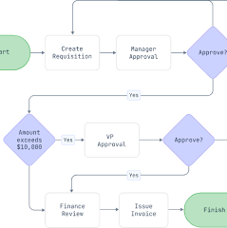
For visualizing an app's build process, beyond flowcharts and UML, several other diagram types offer valuable insights, especially when combined to provide a comprehensive view:
- Data Flow Diagrams (DFDs): These illustrate the flow of data within a system, showing how information moves from inputs through processes and storage to outputs. They highlight the transformations data undergoes and the interactions between different components that handle this data. DFDs are particularly useful for understanding the core functionality of a system and can be created at different levels of detail, starting with a high-level overview (context diagram) and progressively drilling down into subprocesses. They are beneficial for analyzing existing systems for inefficiencies and for designing new systems by modeling data flows and identifying potential bottlenecks.
- Build Pipeline Diagrams (Continuous Integration/Continuous Delivery - CI/CD): These diagrams visualize the automated steps involved in building, testing, and deploying the application. They depict the sequence of actions taken, such as compiling code, running tests, creating deployment packages, and deploying to different environments (e.g., staging, production). Visualizing the CI/CD pipeline helps teams understand the entire delivery process, track progress, identify potential issues, and ensure smooth deployments.
- Deployment Diagrams: These diagrams, often considered a type of UML diagram, focus on the physical architecture of a system by showing how software components are deployed onto hardware infrastructure. They illustrate the nodes (e.g., servers, devices), the artifacts (software components like executables, libraries) deployed on those nodes, and the connections between them. Deployment diagrams are crucial for planning and managing infrastructure, understanding resource allocation, and troubleshooting issues related to deployment or interaction between physical components.
- Network Diagrams: These diagrams represent the network topology and the connections between different network components within the app's build and deployment environment. They can show the flow of information across network devices like routers, switches, and firewalls, as well as connections to external services or databases. Network diagrams help understand network configurations, optimize performance, and identify potential network-related issues or security vulnerabilities.
- C4 Diagrams: This is a lightweight and modern approach to visualizing software architecture that emphasizes different levels of abstraction. The C4 model uses four levels of diagrams: Context, Containers, Components, and Code. Each level provides a different perspective, progressively revealing more detail as needed. This approach helps maintain clarity and ensures that the diagrams remain easy to understand even for non-technical audiences.
These diagrams can be used independently or in conjunction with each other to provide a comprehensive understanding of the app's build process, from the flow of data to the deployment of software onto hardware infrastructure. The specific diagrams chosen will depend on the complexity of the application, the team's needs, and the desired level of detail.
AI responses may include mistakes. Learn more

What info should a build pipeline diagram include?
Build pipeline diagram essentials
A build pipeline diagram, a type of CI/CD pipeline visualization, outlines the stages of continuous integration and delivery. It should provide a clear and concise representation of the automated processes involved in taking code from development to deployment.
1. Key stages
- Source: The starting point where code changes are committed to a version control system like Git, according to KnowledgeHut and Codefresh.
- Build: The stage where the source code is compiled, and dependencies are resolved, creating a deployable artifact like a binary or container image.
- Test: Automated tests (unit, integration, end-to-end) are executed to validate code functionality and quality.
- Deploy (to environment): The process of releasing the tested artifact to different environments (e.g., staging, production), according to Number Analytics and Microsoft Learn.
2. Automated actions/tasks
- Code Compilation: Transforming source code into an executable format.
- Dependency Management: Resolving and fetching external libraries and components.
- Automated Testing: Executing various test suites to ensure code quality and prevent regressions.
- Artifact Generation: Creating the final deployable package or image.
- Security Scans: Automated vulnerability assessments and code quality checks.
- Deployment Script Execution: Automating the deployment of the application to target environments.
3. Environments
Clearly label and differentiate the environments involved, such as:
- Development: Where initial coding and testing occur.
- Staging: A pre-production environment for testing and validation.
- Production: The live environment where the application is accessible to end-users.
4. Tools and technologies
- Version Control: Git, Subversion.
- CI/CD Tools: Jenkins, GitLab CI/CD, CircleCI, Azure DevOps.
- Build Tools: Maven, Gradle, Ant, Docker.
- Testing Frameworks: JUnit, TestNG, PyUnit, Selenium.
- Deployment/Orchestration Tools: Ansible, Puppet, Docker, Kubernetes.
- Monitoring Tools: Prometheus, Grafana, Datadog.
5. Flow and direction
- Use arrows to clearly indicate the sequential flow of tasks and data between stages and environments.
- Show decision points where manual intervention or conditional logic may be involved.
6. Feedback mechanisms
- Indicate how build and test outcomes are reported back to developers.
- Include monitoring and logging to track application performance and identify issues post-deployment.
By incorporating these details into a build pipeline diagram, teams can gain a comprehensive understanding of their CI/CD process, identify areas for improvement, streamline workflows, and ensure the efficient and reliable delivery of high-quality software.
AI responses may include mistakes. Learn more

What are some best practices for visualizing complex CI/CD pipelines?
Best practices for visualizing complex CI/CD pipelines
Visualizing complex CI/CD pipelines requires a thoughtful approach to ensure clarity and effective communication. Here are some best practices:
1. Focus on purpose and target audience
- Tailor the level of detail: The level of detail included in the diagram should depend on the intended audience and the purpose of the visualization. A high-level overview might be sufficient for management, while engineers might need more granular information about each stage and its associated tasks.
- Define clear objectives: Before starting the visualization process, establish what you hope to achieve (e.g., improve pipeline visibility, reduce incident response times, identify bottlenecks).
2. Emphasize clarity and simplicity
- Keep it clean and uncluttered: Avoid overwhelming the diagram with too much information. Use a clean layout with clear separation between stages and actions.
- Use simple, easy-to-understand visualizations: Bar charts, line charts, and pie charts are generally more effective than complex or hard-to-interpret visualizations.
- Employ clear labels and annotations: Explain the data and make it easy for users to understand what each element represents.
- Standardize iconography and color coding: Adopt a consistent set of symbols and colors to represent different stages, actions, and statuses. This improves readability and allows users to quickly grasp the meaning of different elements.
3. Highlight key information
- Prioritize critical metrics: Focus on displaying the most important metrics and KPIs, such as build time, deployment frequency, success/failure rates, test results, and resource usage.
- Visualize the flow of stages and dependencies: Use arrows and connecting lines to clearly illustrate how stages interact and depend on each other.
- Emphasize potential bottlenecks or areas for improvement: Use color, icons, or specific annotations to draw attention to areas that require attention.
4. Leverage the right tools and approaches
- Utilize specialized CI/CD visualization tools: Many CI/CD platforms offer built-in or integrated visualization features. Consider using tools like Grafana, Datadog, or New Relic for comprehensive monitoring and visualization capabilities.
- Consider different levels of abstraction (C4 Model): Adopt the C4 model or a similar approach to visualize the pipeline at different levels of detail, starting with a high-level overview and progressively drilling down into specific stages or components as needed.
- Visualize the pipeline as a Directed Acyclic Graph (DAG): This helps depict the dependencies between steps and track the progress of a running build, according to Buildkite.
5. Promote collaboration and feedback
- Make visualizations accessible to the whole team: Ensure everyone, including developers, QA, and operations, can access and understand the pipeline diagrams.
- Use visualizations as part of incident reviews and retrospectives: Leverage the diagrams to discuss challenges, identify areas for improvement, and collaborate on solutions.
- Encourage continuous feedback and iteration: Regularly gather feedback from the team and refine the visualizations based on their input to ensure they remain valuable and relevant.
By following these best practices, teams can create impactful CI/CD pipeline visualizations that enhance understanding, improve efficiency, and support continuous improvement efforts in the software delivery process.
AI responses may include mistakes. Learn more

What are some useful open-source tools for visualizing CI/CD pipelines?
For visualizing CI/CD pipelines, several open-source tools offer a range of features, from basic pipeline views to advanced analytics and dashboards:
CI/CD platforms with built-in visualization
- Jenkins: As a highly extensible open-source automation server, Jenkins has a vast plugin ecosystem. Plugins like Pipeline Graph View Plugin provide visual representations of pipelines, making it easier to track progress and understand structure. Jenkins also has plugins like Blue Ocean for a more modern UI and Dashboard View for creating custom dashboards. According to Estuary, Jenkins is well-suited for large projects with complex build requirements and self-hosted deployments.
- GitLab CI/CD: Integrated into the GitLab platform, GitLab CI/CD offers a detailed view of pipeline stages, jobs, and their statuses for streamlined monitoring. According to Estuary, GitLab CI/CD is suitable for medium to large projects with varying pipeline complexity, supporting both cloud-based and self-hosted deployment options. It provides a pipeline editor with a visualize tab that shows stages, jobs, and dependencies between them.
- GoCD: This open-source CI/CD server emphasizes value stream mapping and provides detailed pipeline visualizations, helping users optimize workflows.
- Tekton: As a Kubernetes-native framework, Tekton runs CI/CD pipelines directly on Kubernetes and offers reusable, modular components. It integrates with Git providers and cloud services.
- Flux: A GitOps-based continuous delivery tool, Flux for Kubernetes automates deployments based on Git repository changes and provides Kubernetes-native continuous delivery.
- Argo CD: Devtron notes that Argo CD is a declarative, GitOps continuous delivery tool specifically for Kubernetes. It offers a web-based UI that provides visibility into deployment status and allows users to manage applications, manage clusters, and configure Argo CD through the UI and a CLI. It also offers visual pipelines to monitor deployments as they progress and can integrate with Git providers like GitHub and GitLab. Spacelift highlights Argo CD's strength in Kubernetes workflows and its suitability for GitOps implementations.
Top 22 CI CD Tools for your DevOps project in 2025 - BrowserStack
Apr 29, 2025 — Top 22 CI CD Tools for Automation Testing * Jenkins. * GitLab CI/CD. * CircleCI. * Travis CI. * GitHub Actions. * Azure DevOps. * Bitbucket Pipelines. * Bamboo.
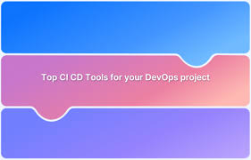

BrowserStack
Getting Started with Argo CD: A Beginner’s Guide - Devtron
Apr 10, 2025 — * Devtron Platform. Unified automation with reusable components for DevOps teams. * Kubernetes Dashboard. Comprehensive Kubernetes monitoring and multi-cluster ...


Devtron
Dashboarding and monitoring tools
- Grafana: A powerful open-source platform, Grafana integrates with numerous data sources, making it ideal for visualizing metrics and creating customizable dashboards related to CI/CD processes. It's often paired with Prometheus for comprehensive monitoring and enables real-time tracking of pipelines.
- Kibana: Primarily a log analysis tool, Kibana can be used to visualize and analyze CI/CD logs, identifying trends and potential issues.
- Powerpipe: This open-source solution focuses on DevOps management and provides tools for visualization and compliance monitoring, facilitating data analysis and informed decision-making.
- MetricFire: Although a commercial offering, MetricFire provides a production-ready Grafana dashboard with automated visualization capabilities, simplifying monitoring and reducing infrastructure management overhead.
General diagramming and visualization tools
- PlantUML/Mermaid: These tools generate diagrams (including flowcharts, sequence diagrams, and more) from text-based descriptions, allowing for quick creation and version control of visualizations.
- Draw.io/Diagrams.net: These free online diagramming tools are excellent for creating various types of diagrams, including CI/CD pipeline visualizations. They offer a wide range of shapes and icons, enabling users to create custom visualizations.
- Graphviz: An open-source graph visualization software, Graphviz can generate diagrams from input text, creating visuals such as flowcharts and network diagrams, which can be useful for illustrating pipeline flow and dependencies.
Remember that the most suitable tools will depend on the specifics of your project and CI/CD setup. Consider factors like ease of integration, scalability, the level of detail required, and your team's familiarity with specific tools when making your decision.
AI responses may include mistakes. Learn more

Elaborate on visualizing Jenkins pipelines with the Pipeline Graph View plugin
Visualizing Jenkins pipelines with the Pipeline Graph View plugin
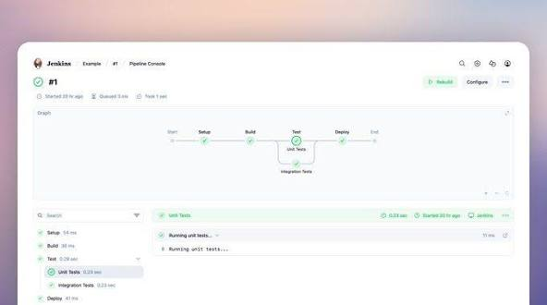
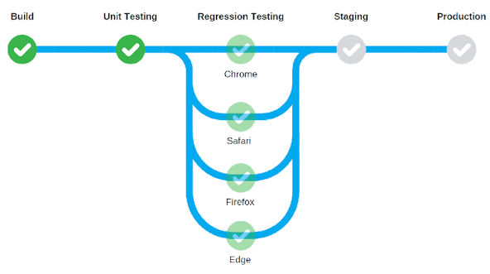
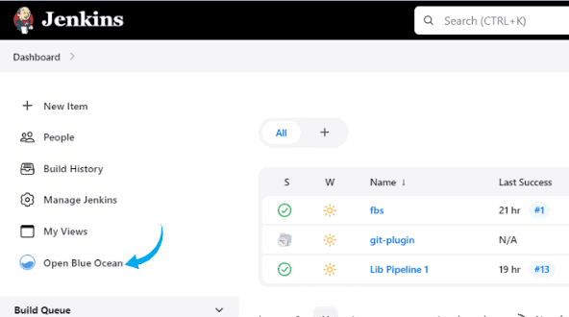
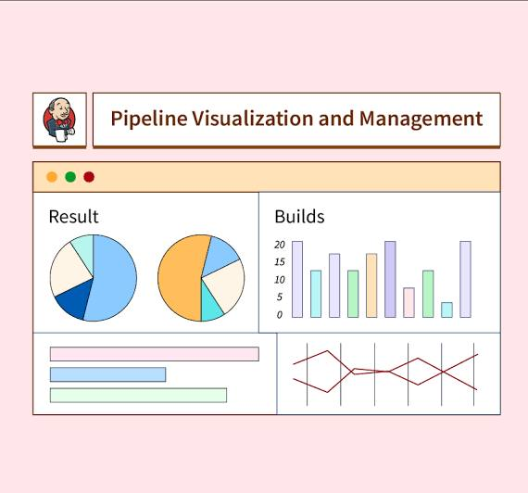
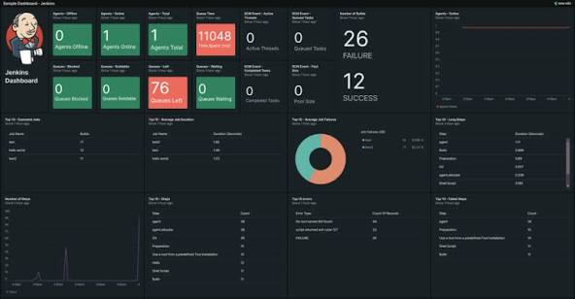
The Pipeline Graph View plugin provides a visual representation of your Jenkins pipelines, enhancing their readability and allowing for quicker analysis of progress and structure. It has undergone a significant rewrite, improving its functionality and user experience.
Key features and functionality
- Interactive, Nested Graph: The plugin displays pipelines as interactive, nested graphs, providing a clear and comprehensive view of each stage and its associated steps.
- Stage-Based Visualization: It presents pipeline stages in a clear and organized manner, allowing for easy navigation and understanding of the pipeline's overall structure.
- Real-time Log Viewing: You can view logs in real time directly within the plugin's interface, eliminating the need to switch to separate log views.
- Customizable Layout: The layout of the graph view is customizable, allowing you to reposition the graph (e.g., to the left for ultrawide displays) and resize or hide columns to suit your preferences.
- Performance Enhancements: The rewritten plugin features significant performance improvements, resulting in faster loading times, smoother scrolling, and better handling of large or complex pipelines.
- Simplified Troubleshooting: By providing a centralized view of the pipeline graph, stage details, and logs, the plugin streamlines the troubleshooting process, making it easier to pinpoint issues and identify bottlenecks.
How to use the Pipeline Graph View plugin
- Installation: Install the "Pipeline Graph View" plugin through your Jenkins Plugin Manager.
- Enable Graph View (Optional): You can enable the graph view to appear on job and build pages by navigating to Manage Jenkins > Appearance and checking the relevant options in the Pipeline Graph View section.
- Access the Graph View: After installing and enabling the plugin, go to a specific pipeline run (not the job page itself).
- Click "Pipeline Console": On the pipeline run page, locate and click the "Pipeline Console" link (or similar, depending on your Jenkins version and theme).
Benefits of using the Pipeline Graph View plugin
- Improved Visibility: Provides a clear visual representation of pipeline progress and status, making it easier for developers, testers, and other stakeholders to understand the pipeline's flow at a glance.
- Faster Troubleshooting: The combined view of the graph, stage details, and logs simplifies troubleshooting and allows for quicker identification of problems or failed stages.
- Enhanced Collaboration: A visual representation of the pipeline fosters better communication and collaboration within the team by offering a common understanding of the CI/CD process.
By leveraging the Pipeline Graph View plugin, you can gain a more comprehensive understanding of your Jenkins pipelines, improve debugging efficiency, and ultimately streamline your CI/CD workflows, especially in the context of complex or parallelized pipelines.
AI responses may include mistakes. Learn more

Show me an example of how the plugin visualizes a complex pipeline
Visualizing complex Jenkins pipelines with the Pipeline Graph View plugin involves seeing the stages and steps laid out visually, rather than just as text or a simple list
.
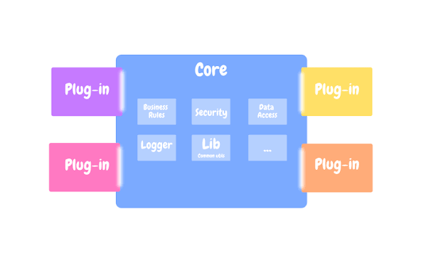
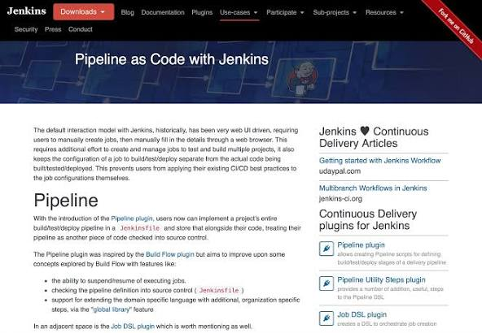
Here's an illustrative example of how the plugin visualizes a complex pipeline, combining various features:
mermaid
graph TD
A[Start] --> B(Checkout Code);
B --> C{Parallel Build};
C --> C1(Build Frontend);
C --> C2(Build Backend);
C1 --> D1(Run Frontend Tests);
C2 --> D2(Run Backend Tests);
D1 --> E(Deploy to Staging);
D2 --> E;
E --> F{Manual Approval};
F --> G(Deploy to Production);
G --> H(Monitor and Log);

subgraph Build Frontend Steps
C1_1(Compile JS/CSS) --> C1_2(Bundle Assets);
C1 --> C1_1;
end

subgraph Build Backend Steps
C2_1(Compile Java Code) --> C2_2(Package JAR);
C2 --> C2_1;
end

subgraph Run Frontend Tests Steps
D1_1(Unit Tests) --> D1_2(Integration Tests);
D1 --> D1_1;
end

subgraph Run Backend Tests Steps
D2_1(Unit Tests) --> D2_2(API Tests);
D2 --> D2_1;
end
Use code with caution.
Explanation of the visualization
- Stages: Each major step in the pipeline is represented by a node (e.g., A, B, C, E, G, H).
- Parallel Stages: The "Parallel Build" stage (C) illustrates a fork in the pipeline where multiple sub-stages run concurrently. The plugin would visually represent this with branching lines or a distinct grouping for these parallel branches.
- Nested Stages/Steps: Within the "Build Frontend" and "Build Backend" stages (C1 and C2), there are nested steps (C1_1, C1_2, C2_1, C2_2). The plugin displays these as smaller, contained elements within their parent stages.
- Dependencies and Flow: Arrows clearly indicate the flow of the pipeline and the dependencies between stages. For example, "Deploy to Staging" (E) depends on both frontend and backend tests completing successfully.
- Conditional Logic (Implicit): While not explicitly represented as a diamond shape like in a traditional flowchart, the "Manual Approval" stage (F) implies a decision point where a human needs to intervene and approve the deployment to production.
- Interactivity: In the actual plugin, you can click on each stage or step to view logs or access further details, according to Jenkins Plugins. You can also reposition the graph or resize elements.
Key takeaways:
- The plugin excels at visualizing complex pipelines with parallel stages and nested steps.
- It provides a more intuitive and readable representation than simply browsing through the pipeline's text-based configuration.
- The interactive nature of the visualization allows for exploring the pipeline and its execution in greater detail.
This example highlights how the Pipeline Graph View plugin can transform a complex, multi-stage, and potentially parallelized Jenkins pipeline into a visually digestible format, aiding in understanding, monitoring, and debugging the CI/CD process.
Keeping track of app development code and build schematics
Effective code management and build process visualization are crucial for the success of any app development project. Here's what an app development project should have in place:
1. Code management
- Version Control System (VCS): A VCS is essential for tracking and managing changes to the source code.
  - Distributed VCS (DVCS) like Git: These are highly recommended as they allow developers to work offline, enable seamless merging, and offer robust features for collaboration like branching and merging. Popular choices include GitHub and GitLab.
  - Branching Strategy: Implement a clear branching strategy (e.g., Gitflow) to manage features, releases, and hotfixes without disrupting the main codebase.
  - Commit Conventions: Establish guidelines for writing clear and concise commit messages to provide a comprehensive history of changes.
- Code Review Process: Regularly review code with the team to identify areas for refactoring, ensure quality, and prevent bugs.
- Documentation: Documenting code and architectural decisions is essential for onboarding new team members and maintaining the project over time.
  - API Documentation: Document the functionality, parameters, and return values of functions and modules.
  - Architectural Documentation: Clearly outline the app's architecture, including its structure, components, and interactions.
- Automated Testing: Implement automated tests (unit, integration, and end-to-end) to ensure code functionality and prevent regressions.
What are the best practices for code organization in large ...
Jun 5, 2024 — Table of Contents * Modularity in Code Design. * Naming Conventions and Standards. * Documentation Best Practices. * Version Control Strategies. * Automated Tes...


www.nucamp.co
Version Control For Mobile Apps - Meegle
Definition and Core Concepts of Version Control for Innovation. Version control for innovation refers to the systematic management of changes to ideas, designs,

Meegle
2. Build process visualization (schematics)
- App Development Process Flowchart: A flowchart can provide a high-level overview of the app's development journey, from concept to deployment and maintenance.
- Software Architecture Diagram: Visually represent the app's architecture, including its core components (e.g., UI, backend services, databases) and their interactions.
  - UML Diagrams: Consider using UML diagrams, particularly structural diagrams like class diagrams, component diagrams, and deployment diagrams, to illustrate the app's static structure and component relationships.
  - Activity Diagrams: Use activity diagrams to depict the flow of control within the system and visualize the dynamic behavior of the app, including various activities and associated conditions.
- CI/CD Pipelines: Implement Continuous Integration/Continuous Delivery (CI/CD) pipelines to automate the build, test, and deployment process.
  - Visualizing the CI/CD pipeline helps understand the automated steps involved in building, testing, and deploying the app.
By adopting these practices, app development projects can maintain a well-organized codebase, streamline the development process, improve collaboration, and ensure the delivery of high-quality applications.
AI responses may include mistakes. Learn more

What other diagrams are useful for visualizing an app's build process besides flowcharts and UML?

For visualizing an app's build process, beyond flowcharts and UML, several other diagram types offer valuable insights, especially when combined to provide a comprehensive view:
- Data Flow Diagrams (DFDs): These illustrate the flow of data within a system, showing how information moves from inputs through processes and storage to outputs. They highlight the transformations data undergoes and the interactions between different components that handle this data. DFDs are particularly useful for understanding the core functionality of a system and can be created at different levels of detail, starting with a high-level overview (context diagram) and progressively drilling down into subprocesses. They are beneficial for analyzing existing systems for inefficiencies and for designing new systems by modeling data flows and identifying potential bottlenecks.
- Build Pipeline Diagrams (Continuous Integration/Continuous Delivery - CI/CD): These diagrams visualize the automated steps involved in building, testing, and deploying the application. They depict the sequence of actions taken, such as compiling code, running tests, creating deployment packages, and deploying to different environments (e.g., staging, production). Visualizing the CI/CD pipeline helps teams understand the entire delivery process, track progress, identify potential issues, and ensure smooth deployments.
- Deployment Diagrams: These diagrams, often considered a type of UML diagram, focus on the physical architecture of a system by showing how software components are deployed onto hardware infrastructure. They illustrate the nodes (e.g., servers, devices), the artifacts (software components like executables, libraries) deployed on those nodes, and the connections between them. Deployment diagrams are crucial for planning and managing infrastructure, understanding resource allocation, and troubleshooting issues related to deployment or interaction between physical components.
- Network Diagrams: These diagrams represent the network topology and the connections between different network components within the app's build and deployment environment. They can show the flow of information across network devices like routers, switches, and firewalls, as well as connections to external services or databases. Network diagrams help understand network configurations, optimize performance, and identify potential network-related issues or security vulnerabilities.
- C4 Diagrams: This is a lightweight and modern approach to visualizing software architecture that emphasizes different levels of abstraction. The C4 model uses four levels of diagrams: Context, Containers, Components, and Code. Each level provides a different perspective, progressively revealing more detail as needed. This approach helps maintain clarity and ensures that the diagrams remain easy to understand even for non-technical audiences.
These diagrams can be used independently or in conjunction with each other to provide a comprehensive understanding of the app's build process, from the flow of data to the deployment of software onto hardware infrastructure. The specific diagrams chosen will depend on the complexity of the application, the team's needs, and the desired level of detail.
AI responses may include mistakes. Learn more

What info should a build pipeline diagram include?
Build pipeline diagram essentials
A build pipeline diagram, a type of CI/CD pipeline visualization, outlines the stages of continuous integration and delivery. It should provide a clear and concise representation of the automated processes involved in taking code from development to deployment.
1. Key stages
- Source: The starting point where code changes are committed to a version control system like Git, according to KnowledgeHut and Codefresh.
- Build: The stage where the source code is compiled, and dependencies are resolved, creating a deployable artifact like a binary or container image.
- Test: Automated tests (unit, integration, end-to-end) are executed to validate code functionality and quality.
- Deploy (to environment): The process of releasing the tested artifact to different environments (e.g., staging, production), according to Number Analytics and Microsoft Learn.
2. Automated actions/tasks
- Code Compilation: Transforming source code into an executable format.
- Dependency Management: Resolving and fetching external libraries and components.
- Automated Testing: Executing various test suites to ensure code quality and prevent regressions.
- Artifact Generation: Creating the final deployable package or image.
- Security Scans: Automated vulnerability assessments and code quality checks.
- Deployment Script Execution: Automating the deployment of the application to target environments.
3. Environments
Clearly label and differentiate the environments involved, such as:
- Development: Where initial coding and testing occur.
- Staging: A pre-production environment for testing and validation.
- Production: The live environment where the application is accessible to end-users.
4. Tools and technologies
- Version Control: Git, Subversion.
- CI/CD Tools: Jenkins, GitLab CI/CD, CircleCI, Azure DevOps.
- Build Tools: Maven, Gradle, Ant, Docker.
- Testing Frameworks: JUnit, TestNG, PyUnit, Selenium.
- Deployment/Orchestration Tools: Ansible, Puppet, Docker, Kubernetes.
- Monitoring Tools: Prometheus, Grafana, Datadog.
5. Flow and direction
- Use arrows to clearly indicate the sequential flow of tasks and data between stages and environments.
- Show decision points where manual intervention or conditional logic may be involved.
6. Feedback mechanisms
- Indicate how build and test outcomes are reported back to developers.
- Include monitoring and logging to track application performance and identify issues post-deployment.
By incorporating these details into a build pipeline diagram, teams can gain a comprehensive understanding of their CI/CD process, identify areas for improvement, streamline workflows, and ensure the efficient and reliable delivery of high-quality software.
AI responses may include mistakes. Learn more

What are some best practices for visualizing complex CI/CD pipelines?
Best practices for visualizing complex CI/CD pipelines
Visualizing complex CI/CD pipelines requires a thoughtful approach to ensure clarity and effective communication. Here are some best practices:
1. Focus on purpose and target audience
- Tailor the level of detail: The level of detail included in the diagram should depend on the intended audience and the purpose of the visualization. A high-level overview might be sufficient for management, while engineers might need more granular information about each stage and its associated tasks.
- Define clear objectives: Before starting the visualization process, establish what you hope to achieve (e.g., improve pipeline visibility, reduce incident response times, identify bottlenecks).
2. Emphasize clarity and simplicity
- Keep it clean and uncluttered: Avoid overwhelming the diagram with too much information. Use a clean layout with clear separation between stages and actions.
- Use simple, easy-to-understand visualizations: Bar charts, line charts, and pie charts are generally more effective than complex or hard-to-interpret visualizations.
- Employ clear labels and annotations: Explain the data and make it easy for users to understand what each element represents.
- Standardize iconography and color coding: Adopt a consistent set of symbols and colors to represent different stages, actions, and statuses. This improves readability and allows users to quickly grasp the meaning of different elements.
3. Highlight key information
- Prioritize critical metrics: Focus on displaying the most important metrics and KPIs, such as build time, deployment frequency, success/failure rates, test results, and resource usage.
- Visualize the flow of stages and dependencies: Use arrows and connecting lines to clearly illustrate how stages interact and depend on each other.
- Emphasize potential bottlenecks or areas for improvement: Use color, icons, or specific annotations to draw attention to areas that require attention.
4. Leverage the right tools and approaches
- Utilize specialized CI/CD visualization tools: Many CI/CD platforms offer built-in or integrated visualization features. Consider using tools like Grafana, Datadog, or New Relic for comprehensive monitoring and visualization capabilities.
- Consider different levels of abstraction (C4 Model): Adopt the C4 model or a similar approach to visualize the pipeline at different levels of detail, starting with a high-level overview and progressively drilling down into specific stages or components as needed.
- Visualize the pipeline as a Directed Acyclic Graph (DAG): This helps depict the dependencies between steps and track the progress of a running build, according to Buildkite.
5. Promote collaboration and feedback
- Make visualizations accessible to the whole team: Ensure everyone, including developers, QA, and operations, can access and understand the pipeline diagrams.
- Use visualizations as part of incident reviews and retrospectives: Leverage the diagrams to discuss challenges, identify areas for improvement, and collaborate on solutions.
- Encourage continuous feedback and iteration: Regularly gather feedback from the team and refine the visualizations based on their input to ensure they remain valuable and relevant.
By following these best practices, teams can create impactful CI/CD pipeline visualizations that enhance understanding, improve efficiency, and support continuous improvement efforts in the software delivery process.
AI responses may include mistakes. Learn more

What are some useful open-source tools for visualizing CI/CD pipelines?
For visualizing CI/CD pipelines, several open-source tools offer a range of features, from basic pipeline views to advanced analytics and dashboards:
CI/CD platforms with built-in visualization
- Jenkins: As a highly extensible open-source automation server, Jenkins has a vast plugin ecosystem. Plugins like Pipeline Graph View Plugin provide visual representations of pipelines, making it easier to track progress and understand structure. Jenkins also has plugins like Blue Ocean for a more modern UI and Dashboard View for creating custom dashboards. According to Estuary, Jenkins is well-suited for large projects with complex build requirements and self-hosted deployments.
- GitLab CI/CD: Integrated into the GitLab platform, GitLab CI/CD offers a detailed view of pipeline stages, jobs, and their statuses for streamlined monitoring. According to Estuary, GitLab CI/CD is suitable for medium to large projects with varying pipeline complexity, supporting both cloud-based and self-hosted deployment options. It provides a pipeline editor with a visualize tab that shows stages, jobs, and dependencies between them.
- GoCD: This open-source CI/CD server emphasizes value stream mapping and provides detailed pipeline visualizations, helping users optimize workflows.
- Tekton: As a Kubernetes-native framework, Tekton runs CI/CD pipelines directly on Kubernetes and offers reusable, modular components. It integrates with Git providers and cloud services.
- Flux: A GitOps-based continuous delivery tool, Flux for Kubernetes automates deployments based on Git repository changes and provides Kubernetes-native continuous delivery.
- Argo CD: Devtron notes that Argo CD is a declarative, GitOps continuous delivery tool specifically for Kubernetes. It offers a web-based UI that provides visibility into deployment status and allows users to manage applications, manage clusters, and configure Argo CD through the UI and a CLI. It also offers visual pipelines to monitor deployments as they progress and can integrate with Git providers like GitHub and GitLab. Spacelift highlights Argo CD's strength in Kubernetes workflows and its suitability for GitOps implementations.
Top 22 CI CD Tools for your DevOps project in 2025 - BrowserStack
Apr 29, 2025 — Top 22 CI CD Tools for Automation Testing * Jenkins. * GitLab CI/CD. * CircleCI. * Travis CI. * GitHub Actions. * Azure DevOps. * Bitbucket Pipelines. * Bamboo.


BrowserStack
Getting Started with Argo CD: A Beginner’s Guide - Devtron
Apr 10, 2025 — * Devtron Platform. Unified automation with reusable components for DevOps teams. * Kubernetes Dashboard. Comprehensive Kubernetes monitoring and multi-cluster ...


Devtron
Dashboarding and monitoring tools
- Grafana: A powerful open-source platform, Grafana integrates with numerous data sources, making it ideal for visualizing metrics and creating customizable dashboards related to CI/CD processes. It's often paired with Prometheus for comprehensive monitoring and enables real-time tracking of pipelines.
- Kibana: Primarily a log analysis tool, Kibana can be used to visualize and analyze CI/CD logs, identifying trends and potential issues.
- Powerpipe: This open-source solution focuses on DevOps management and provides tools for visualization and compliance monitoring, facilitating data analysis and informed decision-making.
- MetricFire: Although a commercial offering, MetricFire provides a production-ready Grafana dashboard with automated visualization capabilities, simplifying monitoring and reducing infrastructure management overhead.
General diagramming and visualization tools
- PlantUML/Mermaid: These tools generate diagrams (including flowcharts, sequence diagrams, and more) from text-based descriptions, allowing for quick creation and version control of visualizations.
- Draw.io/Diagrams.net: These free online diagramming tools are excellent for creating various types of diagrams, including CI/CD pipeline visualizations. They offer a wide range of shapes and icons, enabling users to create custom visualizations.
- Graphviz: An open-source graph visualization software, Graphviz can generate diagrams from input text, creating visuals such as flowcharts and network diagrams, which can be useful for illustrating pipeline flow and dependencies.
Remember that the most suitable tools will depend on the specifics of your project and CI/CD setup. Consider factors like ease of integration, scalability, the level of detail required, and your team's familiarity with specific tools when making your decision.
AI responses may include mistakes. Learn more

Elaborate on visualizing Jenkins pipelines with the Pipeline Graph View plugin
Visualizing Jenkins pipelines with the Pipeline Graph View plugin





The Pipeline Graph View plugin provides a visual representation of your Jenkins pipelines, enhancing their readability and allowing for quicker analysis of progress and structure. It has undergone a significant rewrite, improving its functionality and user experience.
Key features and functionality
- Interactive, Nested Graph: The plugin displays pipelines as interactive, nested graphs, providing a clear and comprehensive view of each stage and its associated steps.
- Stage-Based Visualization: It presents pipeline stages in a clear and organized manner, allowing for easy navigation and understanding of the pipeline's overall structure.
- Real-time Log Viewing: You can view logs in real time directly within the plugin's interface, eliminating the need to switch to separate log views.
- Customizable Layout: The layout of the graph view is customizable, allowing you to reposition the graph (e.g., to the left for ultrawide displays) and resize or hide columns to suit your preferences.
- Performance Enhancements: The rewritten plugin features significant performance improvements, resulting in faster loading times, smoother scrolling, and better handling of large or complex pipelines.
- Simplified Troubleshooting: By providing a centralized view of the pipeline graph, stage details, and logs, the plugin streamlines the troubleshooting process, making it easier to pinpoint issues and identify bottlenecks.
How to use the Pipeline Graph View plugin
- Installation: Install the "Pipeline Graph View" plugin through your Jenkins Plugin Manager.
- Enable Graph View (Optional): You can enable the graph view to appear on job and build pages by navigating to Manage Jenkins > Appearance and checking the relevant options in the Pipeline Graph View section.
- Access the Graph View: After installing and enabling the plugin, go to a specific pipeline run (not the job page itself).
- Click "Pipeline Console": On the pipeline run page, locate and click the "Pipeline Console" link (or similar, depending on your Jenkins version and theme).
Benefits of using the Pipeline Graph View plugin
- Improved Visibility: Provides a clear visual representation of pipeline progress and status, making it easier for developers, testers, and other stakeholders to understand the pipeline's flow at a glance.
- Faster Troubleshooting: The combined view of the graph, stage details, and logs simplifies troubleshooting and allows for quicker identification of problems or failed stages.
- Enhanced Collaboration: A visual representation of the pipeline fosters better communication and collaboration within the team by offering a common understanding of the CI/CD process.
By leveraging the Pipeline Graph View plugin, you can gain a more comprehensive understanding of your Jenkins pipelines, improve debugging efficiency, and ultimately streamline your CI/CD workflows, especially in the context of complex or parallelized pipelines.
AI responses may include mistakes. Learn more

Show me an example of how the plugin visualizes a complex pipeline
Visualizing complex Jenkins pipelines with the Pipeline Graph View plugin involves seeing the stages and steps laid out visually, rather than just as text or a simple list
.


Here's an illustrative example of how the plugin visualizes a complex pipeline, combining various features:
mermaid
graph TD
A[Start] --> B(Checkout Code);
B --> C{Parallel Build};
C --> C1(Build Frontend);
C --> C2(Build Backend);
C1 --> D1(Run Frontend Tests);
C2 --> D2(Run Backend Tests);
D1 --> E(Deploy to Staging);
D2 --> E;
E --> F{Manual Approval};
F --> G(Deploy to Production);
G --> H(Monitor and Log);

subgraph Build Frontend Steps
C1_1(Compile JS/CSS) --> C1_2(Bundle Assets);
C1 --> C1_1;
end

subgraph Build Backend Steps
C2_1(Compile Java Code) --> C2_2(Package JAR);
C2 --> C2_1;
end

subgraph Run Frontend Tests Steps
D1_1(Unit Tests) --> D1_2(Integration Tests);
D1 --> D1_1;
end

subgraph Run Backend Tests Steps
D2_1(Unit Tests) --> D2_2(API Tests);
D2 --> D2_1;
end
Use code with caution.
Explanation of the visualization
- Stages: Each major step in the pipeline is represented by a node (e.g., A, B, C, E, G, H).
- Parallel Stages: The "Parallel Build" stage (C) illustrates a fork in the pipeline where multiple sub-stages run concurrently. The plugin would visually represent this with branching lines or a distinct grouping for these parallel branches.
- Nested Stages/Steps: Within the "Build Frontend" and "Build Backend" stages (C1 and C2), there are nested steps (C1_1, C1_2, C2_1, C2_2). The plugin displays these as smaller, contained elements within their parent stages.
- Dependencies and Flow: Arrows clearly indicate the flow of the pipeline and the dependencies between stages. For example, "Deploy to Staging" (E) depends on both frontend and backend tests completing successfully.
- Conditional Logic (Implicit): While not explicitly represented as a diamond shape like in a traditional flowchart, the "Manual Approval" stage (F) implies a decision point where a human needs to intervene and approve the deployment to production.
- Interactivity: In the actual plugin, you can click on each stage or step to view logs or access further details, according to Jenkins Plugins. You can also reposition the graph or resize elements.
Key takeaways:
- The plugin excels at visualizing complex pipelines with parallel stages and nested steps.
- It provides a more intuitive and readable representation than simply browsing through the pipeline's text-based configuration.
- The interactive nature of the visualization allows for exploring the pipeline and its execution in greater detail.
This example highlights how the Pipeline Graph View plugin can transform a complex, multi-stage, and potentially parallelized Jenkins pipeline into a visually digestible format, aiding in understanding, monitoring, and debugging the CI/CD process.

